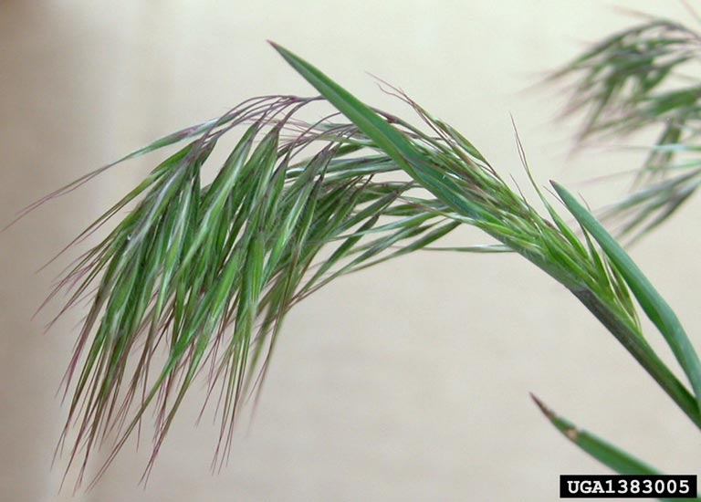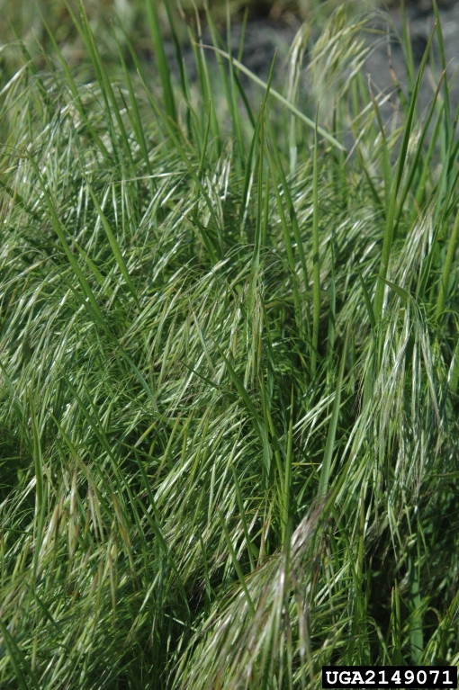

**Have you seen this plant?**

**Features:**

• Annual grass 2-28” tall

• Leaves covered in soft white hairs

• Panicle and leaves often turn purplish-tan as the plant matures

• Drooping panicle with 1” long awns on the seed head

• Produces 300 seeds per plant that can remain viable in the soil for 5 years

*Clockwise from top left:* cheatgrass in midseason; cheatgrass infestation; late season with mature seeds.

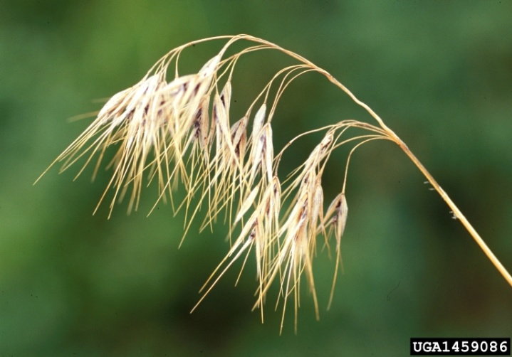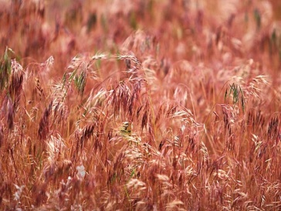

Cheatgrass was found in the Nenana area in 2009. Seeds can spread by wind, attached to animal fur, in contaminated seed/straw/hay, and on equipment. If you spot cheatgrass on your property, please **pull the plant immediately and dispose in a plastic trash bag** to prevent seeds from spreading.

**Contact FSWCD to let us know**! We can help you decide how to deal with future infestations, including mechanical and herbicide options.

**Why you don’t want cheatgrass in your fields:**

• it is hard to clean from crops and can contaminate seed

• It will decrease the quality of your forage, therefore decreasing profits

• The sharp spikelets and long, rough awns can cause problems for livestock - damaging the mouth and eyes if ingested (much like a foxtail)

• It increases the chance and intensity of wildfires because of the dry plant material left after it seeds

**Cheatgrass, *Bromus tectorum***

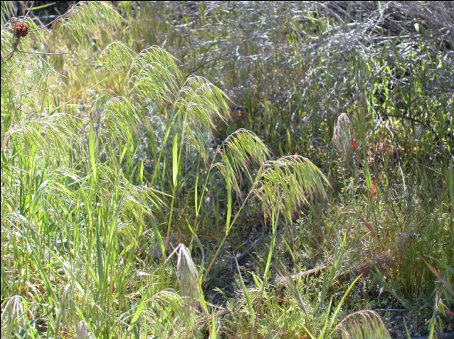

For more info or to report a sighting, please contact:

**Fairbanks Soil & Water Conservation District**

**Darcy Etcheverry, 479-1213** or

**FSWCD.tech@gmail.com**